#### **Board of Directors**

#### **New Board Member Orientation**

**St. Paul of the Cross Passionist**

**Retreat and Conference Center**

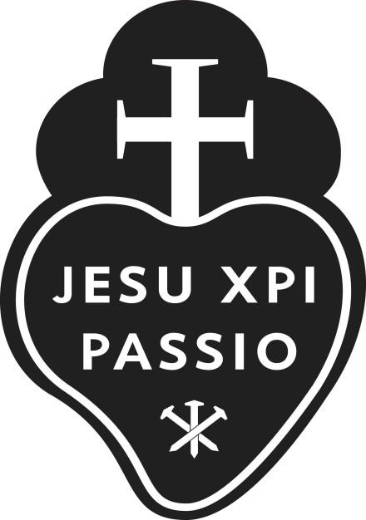

**Published: 2023-06-24**